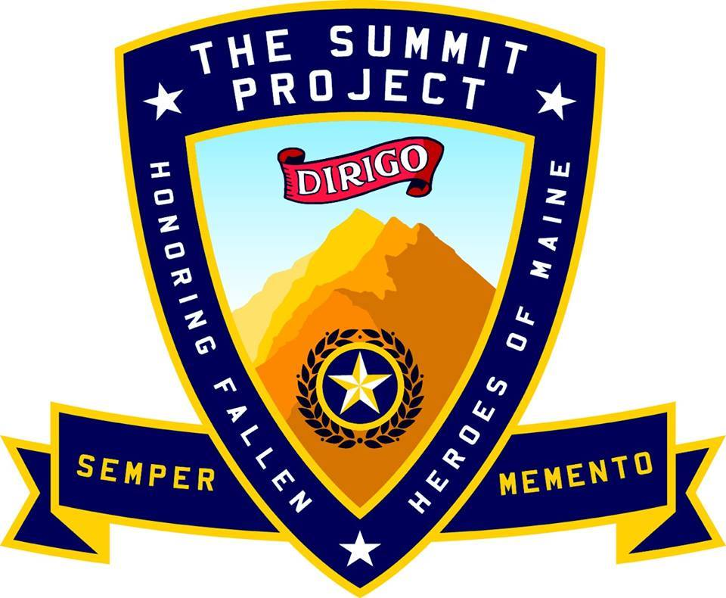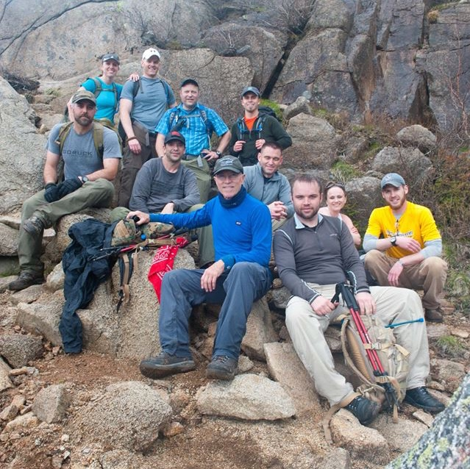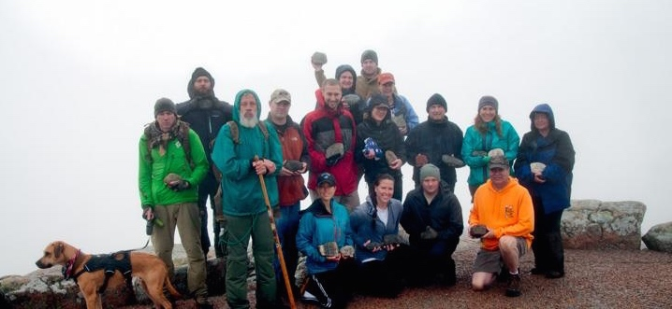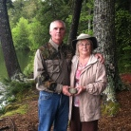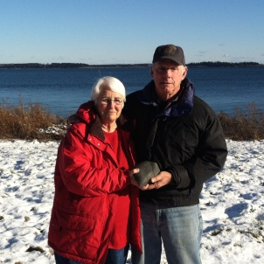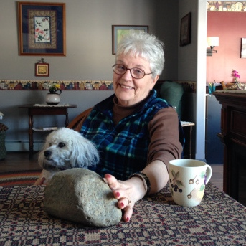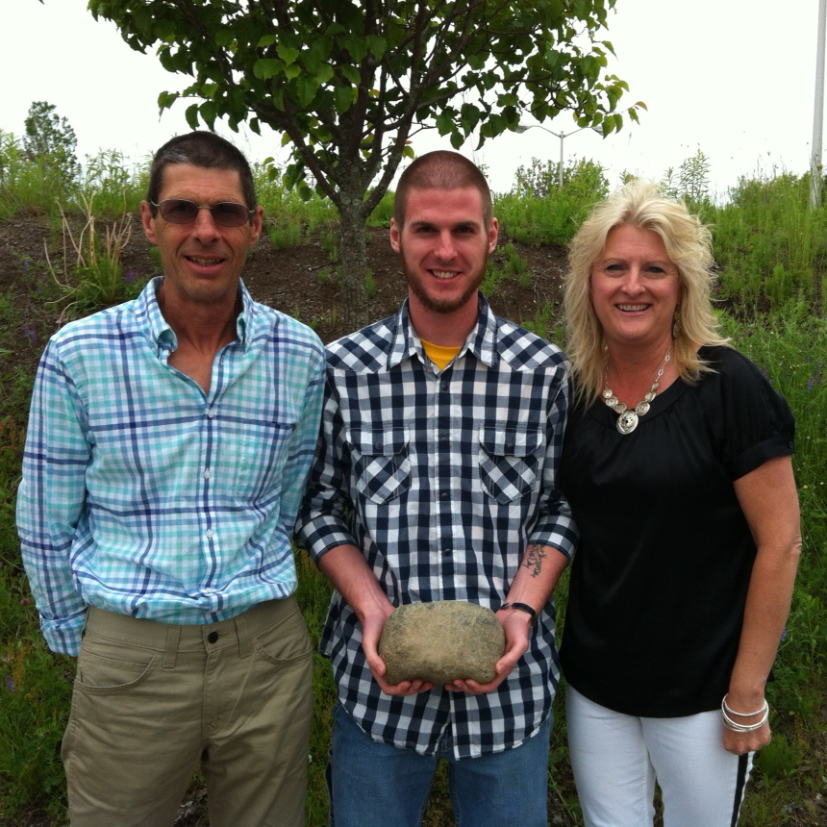

The Summit Project is a living memorial that has changed the way Maine pays tribute to our post 9/11 fallen heroes. The mission of The Summit Project is to honor our state’s newest war casualties and the faithful spirit of all Mainers. The surviving families of Maine’s fallen heroes have made this project a success. They have opened their homes and their hearts, shared the stories of our heroes’ character and service and have unearthed and donated a special stone that represents their loved one. We’ve engraved those stones and starting on Memorial Day 2013, volunteers have hiked up and down mountains in Maine and across the world carrying these tribute stones in their packs, making the Summit Project a living memorial. The stories and stones of our fallen and been carried and shared on Katahdin, Kilimanjaro, Everest, Denali and through parades, marathons and marches all across Maine and the US. Our heroes’ memories remain alive and our tribute hikes have become a symbol of solidarity that recognizes the burden shouldered by our brave Maine service members and their families. The Summit Project has also revealed the character of Maine. As Mainers, we look after one another, we remember one another, we make sacrifices for one another, we are faithful to each other and we carry each other to higher places, both literally and figuratively. We are able to carry on the unfinished work of our fallen toward creating a safer, sounder, more just America. www.thesummitproject.org

Major David J. Cote USMCR Founder The Summit Project

D

D

D

D

D

D

D

D

D

D

D

D

D

D

D

D

D

D

D

d

We carry their stone for a hike

We carry their story for a lifetime

The Summit Project